Experiment No. – 1
Date of Performance: | 15/7/2025
Date of Submission: | 22/7/2025
Program Execution/  formation/  correction/  ethical practices  (06) | Timely  Submission  (01) | Viva  (03) | Experiment  Total (10) | Sign with Date

Experiment No. 1
Operation on a dataset by Bayesian Network in Python.

1.1 Aim: Implementation of different operation on a dataset by Bayesian Network in Python.

1.2 Course Outcome: Understand uncertainty processes and cognitive computations and
applications.

1.3 Learning Objectives: Implement reasoning with uncertainty.

1.4 Requirement:Python (Google Colab), Dataset Used:kaggle

1.5 Related Theory:

Bayesian Network
Bayesian networks are a type of Probabilistic Graphical Model that can be used to build models from data and/or expert opinion. They can be used for a wide range of tasks including diagnostics,reasoning, causal modeling, decision making under uncertainty, anomaly detection, automated dinsight and prediction. Bayesian networks are probabilistic because they are built from probability distributions and also use the laws of probability for Reasoning, Diagnostics, Causal AI, Decision making under uncertainty, and more.
Conditional Probability
The conditional probability of an event B is the probability that the event will occur given the
knowledge that an event A has already occurred. This probability is written P(B|A), notation for the probability of B given A. In the case where events A and B are independent (where event A has no effect on the probability of event B), the conditional probability of event B given event A is simply the probability of event B, that is P(B). If events A and B are not independent, then the probability of the intersection of A and B (the probability that both events occur) is defined by
P (A and B) = P(A)P(B|A).
Joint Probability
The term joint probability refers to a statistical measure that calculates the likelihood of two events occurring together and at the same point in time. Put simply, a joint probability is the probability of event Y occurring at the same time that event X occurs. In order for joint probability to work, both events must be independent of one another, which means they aren't conditional or don't relyon each other. Joint probabilities can be visualized using Venn diagrams.
Posterior Probability
A posterior probability is the updated probability of some event occurring after accounting for new information.For example, we might be interested in finding the probability of some event “A”occurring after we account for some event “B” that has just occurred. We could calculate this
posterior probability by using the following formula:

P(A|B) = P(A) * P(B|A) / P(B)

where: P(A|B) = the probability of event A occurring, given that event B has occurred.
P(A) = the probability that event A occurs.
P(B) = the probability that event B occurs.
P(B|A) = the probability of event B occurring, given that event A has occurred.

Mathematical Definition of Belief Networks
Bayesian belief network is key computer technology for dealing with probabilistic events and to solve a problem which has uncertainty. We can define a Bayesian network as: “A Bayesian
network is a probabilistic graphical model which represents a set of variables and their conditional dependencies using a directed acyclic graph.” It is also called a Bayes network, belief network,decision network, or Bayesian model.
Bayesian networks are probabilistic, because these networks are built from a probability
distribution, and also use probability theory for prediction and anomaly detection. The Bayesian Belief Network is based on the Bayes Theorem.
Bayesian Theorem
For two random variables X and Y, the following equation holds-
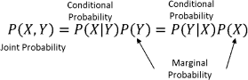

If the X and Y are independent of each other then

Joint Probability
Given X1, X2,………,Xn are features (nodes) in a BBN. Then Joint probability is defined as:
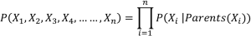

Marginal Probability
Given the joint probability, marginal probability of X1 = x0 is calculated as:
where x2 ,x3,…xn are the set of values corresponding to X2, X3,…..,Xn

Belief Propagation
Now let us try to understand belief propagation with the help of an example. We will consider an elementary network.
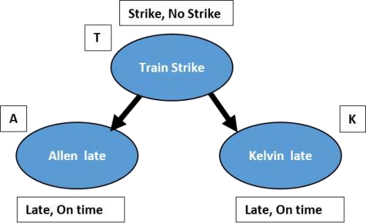

1.6 Procedure:

Write a Python program to build the Bayesian Network model, Train, validate and evaluate it.

1.7 Program and Output:

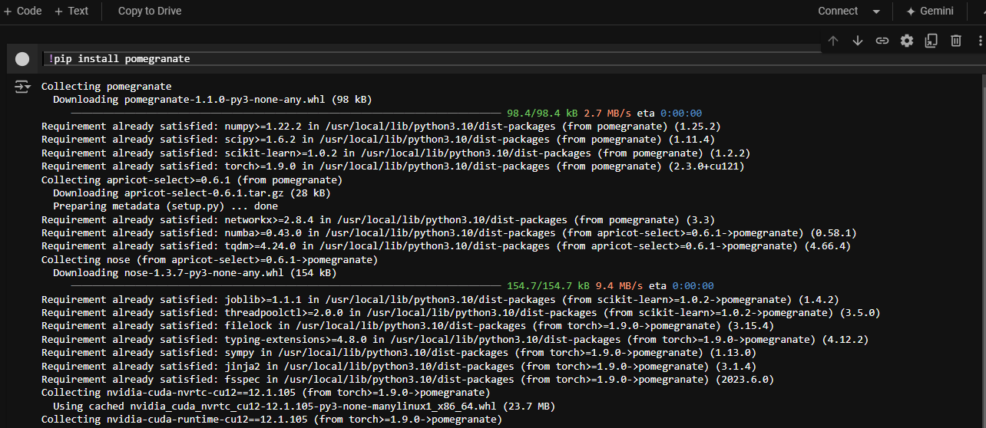

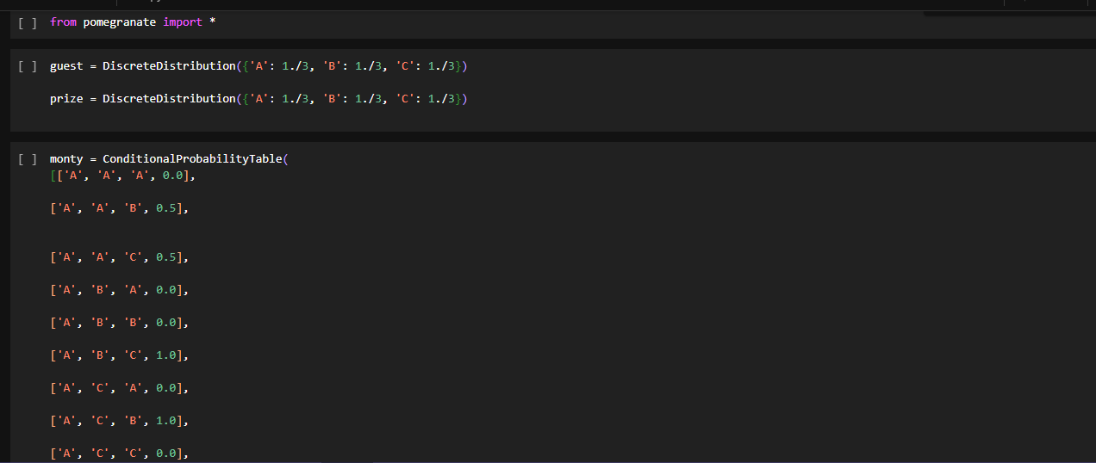
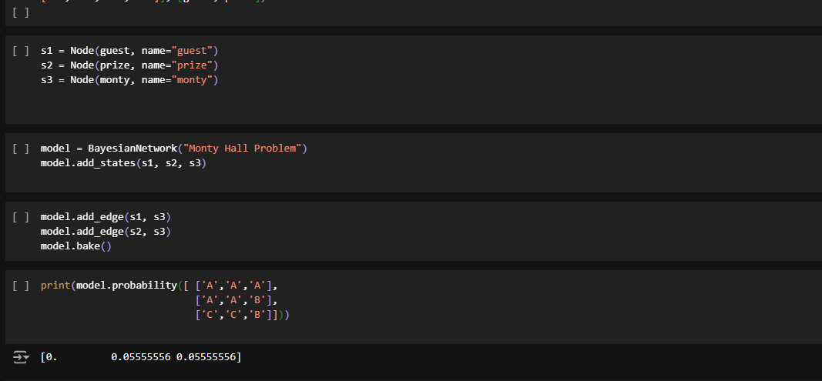

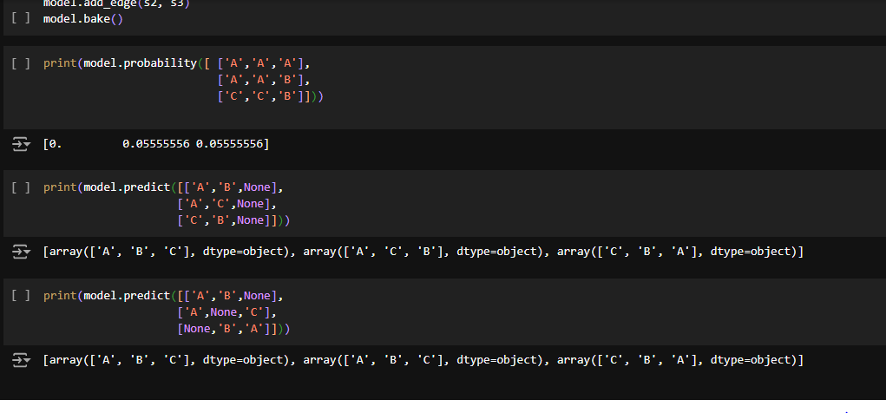

1.8 Conclusion:
In this experiment, we successfully implemented operations on a dataset using a Bayesian Network in Python. We demonstrated how to define the structure of a Bayesian Network, estimate the parameters from data, and perform probabilistic inference. Bayesian Networks provide an efficient way to represent complex probabilistic relationships, allowing us to compute both marginal and conditional probabilities. The use of Python libraries like pgmpy simplifies the construction and analysis of Bayesian Networks, making them accessible for solving real-world probabilistic problems.

1.9 Questions:
1.Explain the Problem of Bayesian Network.
Ans:
The use of Bayesian Networks in AIDS management addresses uncertainties in diagnosis, disease progression, and treatment outcomes. AIDS presents challenges in accurate diagnosis due to varied symptoms and the limitations of diagnostic tests. Bayesian Networks improve diagnostic precision by integrating multiple test results and updating the likelihood of HIV infection as new evidence becomes available. They also help predict disease progression by modeling relationships between factors like viral load, immune response, and treatment adherence, providing a personalized approach to managing the disease.
For treatment decision-making, Bayesian Networks support the selection of the most effective therapies by considering patient characteristics, treatment options, and the associated risks of side effects. They assess the probabilities of different outcomes, helping to tailor treatments to individual needs. Additionally, Bayesian Networks can estimate the risk of opportunistic infections, allowing for proactive preventive measures. The main challenges include the need for high-quality data, the complexity of large networks, and the dynamic nature of the disease, requiring continuous network updates to reflect changes in the patient’s condition. Despite these, Bayesian Networks offer a powerful tool for enhancing decision-making and patient care in AIDS management.

2.What is the joint probability of Bayesian Network?
Ans:
In a Bayesian Network, the joint probability distribution represents the probability of all possible combinations of the variables in the network occurring simultaneously. A Bayesian Network uses a directed acyclic graph (DAG) where each node represents a random variable, and the edges indicate conditional dependencies between these variables.
The joint probability of a set of variables X1, X2, ..., Xn​ in a Bayesian Network can be calculated by multiplying the conditional probabilities of each variable given its parents in the network. If a variable has no parents, it is treated as an unconditional probability. Mathematically, the joint probability is given by:
P(X1,X2,...,Xn)=∏ P( Xi ∣ Parents(Xi))
Here:
- P( Xi ∣ Parents(Xi)) represents the conditional probability of Xi​ given its parent nodes.
- If a variable Xi​ has no parents, P( Xi ∣ Parents(Xi)) is simply P(Xi), the marginal probability of Xi​.

